3.11: Take 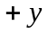 to be upward.
Use Chirpy’s motion to find the height of the cliff.
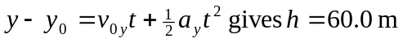
Milada: Use vertical motion to find time in the air.
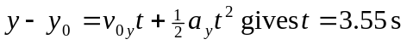
Then 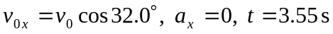 gives 

